**JacquardFunctionalTesting - Processing: Guide for Innorev**

Author(s): [wtony@google.com](mailto:wtony@google.com)

03/07/2019

OS: Windows 10

**Generate Executable:**

1. [Download and Install Processing](http://download.processing.org/processing-3.5.3-windows64.zip)
2. [Download folder containing JacquardFunctionalTesting.pde](https://drive.google.com/corp/drive/folders/1sAZJ3eq9o-tN_YT7_NuV_o4wbLdvF2BP)
3. Run the .pde in Processing
4. File->Export Application
   1. Check Windows
   2. Check Embed Java for Windows (64-bit)

**How to run the Application:**

1. Plug in communication box (make sure it’s the only COM port on the PC)
2. Run the Executable generated from above.
3. Follow the on-screen prompts:
   1. 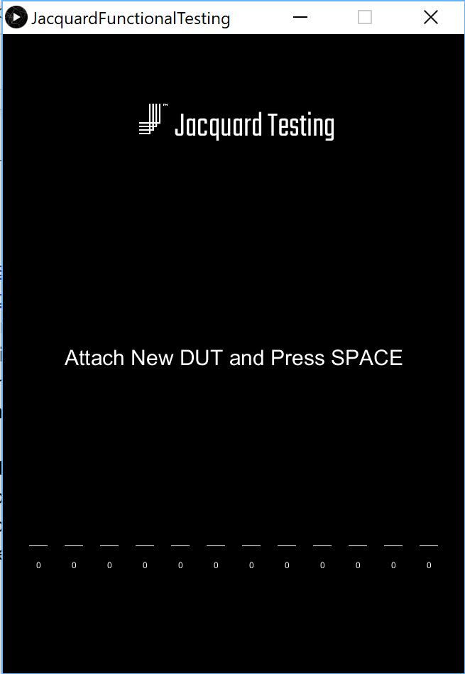
   2. 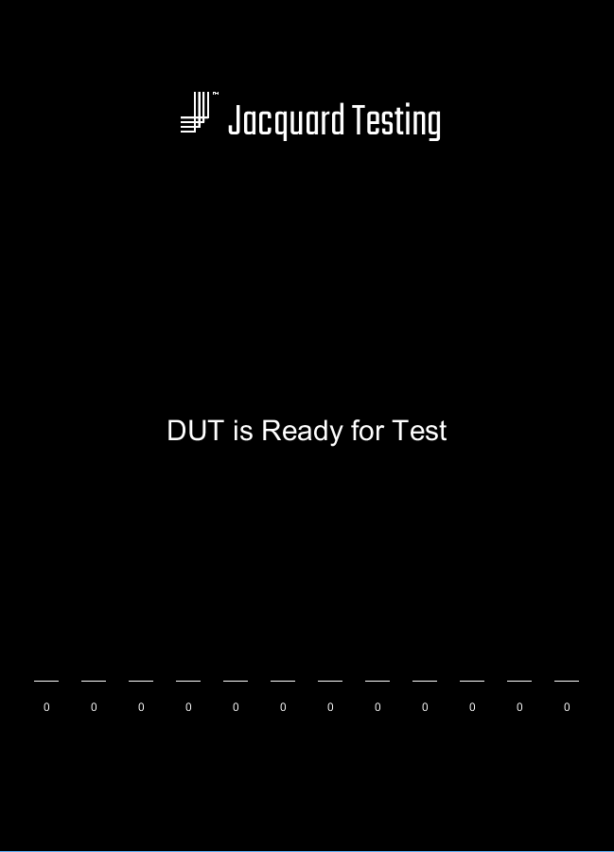
      1. Toggle the ‘m’ key to check if haptics is working.
      2. Press ‘t’ to start touch sensor testing.
   3. 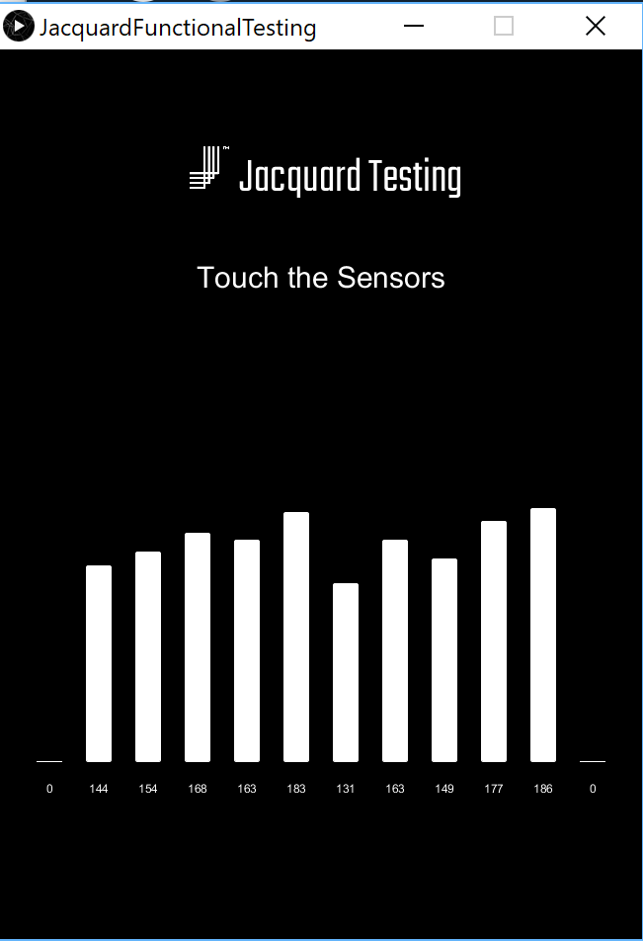
      1. Touch the sensors and see if the middle 10 lines are responsive (for Levi’s)
      2. Press “ENTER” to complete the test and start a new one.